

THE TECHNICAL UNIVERSITY OF KENYA

SCHOOL OF COMPUTING AND INFORMATION TECHNOLOGY

DEPARTMENT OF INFORMATION SYSTEMS AND TECHNOLOGY

**SCIT STUDENTS PROJECT PROGRESS MANAGEMENT SYSTEM (SCIT SPPMS)**

A CASE STUDY OF THE SCHOOL OF COMPUTING AND INFORMATION TECHNOLOGY AT THE TECHNICAL UNIVERSITY OF KENYA

PRESENTED BY:

**CHARLES KAIRU**

**SCII/00329/2016**

SUPERVISED BY:

MR. PETER KARIUKI

MS. NJERI NGARUIYA

A PROJECT PROPOSAL SUBMITTED TO THE SCHOOL OF COMPUTING AND INFORMATION TECHNOLOGY IN PARTIAL FULFILMENT FOR THE DEGREE OF TECHNOLOGY IN INFORMATION TECHNOLOGY PROJECT OF THE TECHNICAL UNIVERSITY OF KENYA

SUBMISSION DATE:

**JANUARY 2020**

# DECLARATION PAGE

I hereby declare that the project report entitled “SCIT STUDENTS PROJECT PROGRESS MANAGEMENT SYSTEM (SCIT SPPMS)” submitted by me to the School of Computing and Information Technology at The Technical University of Kenya; is my original work and has never been submitted to any other institution for the award of certificate, Diploma or Degree

Name: **Charles Kairu** Signature:…………………………………………………………………….

Date:………………………………………………………………………….

This project has been submitted for examination with our approval as supervisors.

MR. PETER KARIUKI

Signature:…………………………………………………………………….

Date:………………………………………………………………………….

MS. NJERI NGARUIYA

Signature:…………………………………………………………………….

Date:………………………………………………………………………….

# TABLE OF CONTENT

DECLARATION PAGE 1

TABLE OF CONTENT 2

LIST OF TABLES 3

LIST OF FIGURES / ILLUSTRATIONS 4

1 CHAPTER ONE 5

1.1 Introduction: 5

1.2 Background of the Study 5

1.3 Problem Statement(s) 6

1.4 Objectives: - 6

1.5 Scope and Limitation of the Study 7

1.6 Justification; - 7

1.7 Project Risk and Mitigation; - 7

1.8 Budget and Resources; - 8

2 CHAPTER TWO: LITERATURE REVIEW 10

2.1 Introduction 10

2.2 A Proposal for Final Year Project Monitoring and Assessment System 10

2.3 An Implementation of Final Year Project Management System : A Case Study at Universiti Sultan Zainal Abidin 10

2.4 International Journal of Advanced and Applied Sciences Implementation of fuzzy logic-based final year project student-supervisor matching system 11

2.5 Technology in Education: Transforming Educational Practices with Technology: First International Conference 12

2.6 Project Management System ( PMS ) 13

3 CHAPTER THREE: METHODOLOGY 14

3.1 Introduction 14

3.2 The SDLC Methodology 14

3.3 Sources of Data 15

*3.3.1* *Primary data* 15

*3.3.2* *Secondary data* 16

3.4 Data analysis 16

3.5 Tools to implement and test the system 16

4 CHAPTER FOUR: SYSTEM ANALYSIS AND REQUIREMENT MODELING 18

4.1 Introduction 18

4.2 How the facts and data of the current system were gathered 18

4.3 Requirement definitions of the current system 18

4.4 Requirement definitions and specifications of the proposed system 19

4.5 Data Flow Diagrams 22

4.6 Use Case Diagram 25

4.7 Class Diagram 26

4.8 Flowcharts 27

5 CHAPTER FIVE: SYSTEM DESIGN 31

5.1 Introduction 31

5.2 Wireframes 31

5.3 Database schema 37

6 CHAPTER SIX SYSTEM IMPLEMENTATION 42

CONCLUSION 43

REFERENCE 44

7 Appendix 45

# LIST OF TABLES

Table 1: Budget 8

Table 2: Project Schedule 9

# LIST OF FIGURES / ILLUSTRATIONS

Figure 1: Level 0 DFD 23

Figure 2: Level 1 DFD 24

Figure 3: Level 2 DFD 25

Figure 4: Use case diagram 26

Figure 5: Class Diagram 27

Figure 6: Sign Up & Sign In flowchart 28

Figure 7: Students’ flowchart 29

Figure 8: Supervisors’ flowchart 30

Figure 9: Project coordinators’ flowchart 31

Figure 10: Sign Up wireframe 32

Figure 11: Login wireframe 33

Figure 12: Students’ dashboard wireframe (a) 33

Figure 13: Students’ dashboard wireframe (b) 34

Figure 14: Add project wireframe 34

Figure 15: Add milestone wireframe 35

Figure 16: Supervisors’ dashboard wireframe 35

Figure 17: Approving milestones wireframe 36

Figure 18: Project coordinator’s dashboard wireframe (a) 36

Figure 19: Project coordinator’s dashboard (b) 37

Figure 20: Conceptual database design 38

Figure 21: Logical database design 39

Figure 22: Allocations’ schema 40

Figure 23: Projects’ schema 40

Figure 24: Milestones’ schema 41

Figure 25: Students’ schema 41

Figure 26: Project coordinator’s schema 42

Figure 27: Supervisors’ schema 42

## CHAPTER ONE

### Introduction:

SCIT Students Project Progress Management System (SCIT SPPMS) will be a web application whose main goals will be to improve students time management when doing their projects and to eliminate paperwork in management of students’ project progress by allowing students to create milestones and monitor the progress of their projects, the supervisors to access students’ milestones, fill evaluation remarks and approve various milestones and the project co-ordinator to allocate supervisors and monitor the projects evaluation progress.

### Background of the Study

The final year project is an important exercise for every student at The Technical University of Kenya. It involves putting the skills learned since the first year into practice. Some students fail to complete their projects by the end of the expected period due to poor time management. This may lead to low grading of their projects either because the projects were done in a hurry towards the end of the period or due to lack of enough time to prepare for a presentation. In some cases, it is even a bigger threat in which the students may fail to graduate due to incomplete projects and therefore costs them another year at the university.

#### Overview of the current system

In order to help students in completing their projects and make sure they are on the right track; each student is assigned at least two mentors who offer more insight on the students' project ideas and generally guide them through the process. The whole project is divided into two, Project A and Project B. Each of these two divisions are further divided into various milestones.

The project co-ordinator sends the students’ project progress form to every student via email. The students are then supposed to download this form and curry it every time they are meeting with their supervisors for them to fill in issues raised in the current milestone. The supervisors then sign after addressing the issues raised for a particular milestone. For a student to present their project, they must have completed all the necessary milestones which must have been approved by their supervisors by signing on the student project progress report.

#### Problems in the current system

1. Use of paperwork to manage projects. Papers can easily be misplaced and untidy.
2. Poor time management which makes the projects to be done in a hurry toward the end of the expected period.

#### Overview of the proposed system

The system will allow students to break the project into various milestones and allocate an estimated period of completing each milestone. This will help students to know whether they are behind, on or ahead of schedule and reduce paperwork by allowing supervisors to approve project milestones via the system. For the student and supervisors to use the system, they will be required to register as a user and log in using a username and a password. Students are allowed to create and view various milestones but not to approve them. The system will be developed using React.js on the frontend and, JavaScript and Firebase on the backend.

#### Benefits of the proposed system

1. It will eliminate paperwork
2. It will improve time management

### Problem Statement(s)

Students’ project progress management at SCIT is currently done manually by use of paperwork. This tends to be a less effective way of managing students’ project progress due to printing costs, forgery and misplacement of project progress papers. There is also lack of a proper time management system that enables the students, supervisors and project coordinator to monitor the progress of the final year projects. Poor time management during the final year projects leads to low quality of work or incomplete projects which may cost the students low grades and in worst cases, another year at the university.

### Objectives: -

**General objectives**

1. To develop a web application that automates the final year project progress management procedures at SCIT.

**Specific objectives**

1. To develop a module that allows students to create milestones and monitor their project progress.
2. To develop a module that allows supervisors to access students’ milestones, fill evaluation remarks and approve students’ milestones.
3. To develop a module that enables the project coordinator to allocate supervisors to students and monitor the projects evaluation progress.

### Scope and Limitation of the Study

**In scope**

1. **Registering users –** The system will enable students and supervisors to register as users.
2. **Signing in users –** The system will allow registered users to log in to the system.
3. **Creating Milestones –** The system will allow students to create new milestones.
4. **Evaluating and Approving Milestones –** Supervisors will be able to access students’ milestones, fill evaluation remarks and approve students’ milestones.
5. **Allocating supervisors –** The project co-ordinator will be able to allocate supervisors to students and monitor project evaluation progress.

### Justification; -

Having a system that monitors the progress of the students' projects will lead to increased efficiency and quality of work. This will also help students to have less pressure towards the end of the project period by completing milestones in time and thus having enough time to prepare for presentations.

The system will make approval of milestones by the supervisors much easier than the use of papers. Papers can also be easily lost than data which is stored safely in the database. The reduction of paperwork will also lead to cost-saving.

To ensure control, the system will have three user roles. The student who will be able to create milestones and monitor their progress, the supervisor who will be able to give evaluation remarks and approve milestones and project coordinator who will be able to allocate supervisors.

### Project Risk and Mitigation; -

* **Loss of source code** due to virus attacks, laptop theft, developer error (accidental deletion of files) and other possible causes. This risk will be neutralized by using git and GitHub to safely store the source code and track changes that are made on the code.
* **Time risk** – Failure to meet the deadline is a major risk. Setting SMART objectives and using tools such as Gantt charts and network diagrams will help to determine the progress and critical path of the project. (S - Specific, M - Measurable, A - Achievable, R- Realistic/Relevant, T- Time-bound/boxed)

### Budget and Resources; -

#### Budget

Table 1: Budget

|  |  |
| --- | --- |
| **Items** | **Cost (Ksh.)** |
| Computer/Laptop | 40,000 |
| Internet access | 12,000 (6 months) |
| Code Editor (Preferred Visual Studio Code) | Null |
| Git and GitHub | Null |
| Firebase | Null |
| Ms. Word/PowerPoint | 3,000 |
| **Total** | 55,000 |

#### Resource Requirements

**Recommended Operating Systems:**

* **Windows:**10
* **MAC:** OS X v10.7 or higher
* **Linux:** Ubuntu

**Hardware Requirements:**

* Processor: Minimum 1.4 GHz; Recommended 2GHz or more
* Ethernet connection (LAN) OR a wireless adapter (Wi-Fi)
* Hard Drive: Minimum 32 GB; Recommended 64 GB or more
* Memory (RAM): Minimum 2 GB; Recommended 4 GB or above

**Software Requirements:**

* Code Editor: Recommended Visual studio code 2017
* Version Control System: Recommended GitHub
* Browser: Recommended Chrome
* Word processor: Recommended Microsoft Word

#### Project Schedule: -

Table 2: Project Schedule

|  |  |  |  |
| --- | --- | --- | --- |
| **Task** | **Description** | **Duration** | **Date (2020)** |
| Task 1 | Requirement Modelling | 14 days | 15 Jan – 28 Jan |
| Task 2 | System Design | 14 days | 29 Jan – 11 Fed |
| Task 3 | Coding | 35 days | 12 Feb – 17 March |
| Task 4 | Unit testing | 35 days | 12 Feb – 17 March |
| Task 5 | System testing | 7 days | 18 March -24 March |
| Task 6 | Deployment | 7 days | 25 March – 31 March |
| Task 7 | Documentation | 77 days | 15 Jan – 31 March |

## CHAPTER TWO: LITERATURE REVIEW

### Introduction

Literature review refers to discussions of published scholarly papers in a particular subject area. The following is the review of existing systems that are similar to SCIT SPPMS. This is helpful in gathering knowledge on how similar systems were developed, identifying gaps in these systems and making sure that this research study does not simply duplicate an already existing system.

### A Proposal for Final Year Project Monitoring and Assessment System

#### Overview

A system similar to SCIT SPPMS was proposed at Mumbai University after they included final year projects in their syllabus for final year engineering students. The main function of the system proposed by (Thorat, Rahate, Jaiswal, & Gadhave, 2018) is to reduce duplication of project ideas and paperwork at the university. The system is a combination of a web portal where each user has a unique login, document repository system for storing past project abstracts and notification system.

#### Benefits

1. The system allows students to form groups
2. Communication between users is supported
3. Mapping of student groups and guides(supervisors) is done automatically by the system
4. Students can submit their reports via the system for assessment by their guides

#### Limitation

The main limitation of this system is that, despite one of its objective beings to reduce duplication of ideas, it only allows students to view past project ideas and not current once and there are no proper measures taken to completely avoid duplication of the projects.

#### How this system is different from the proposed system

The main difference between this system and the proposed SCIT SPPMS is that the projects are done in groups unlike at SCIT where projects are individual work. It does not provide a proper time management system, unlike SCIT SPPMS will allow users to divide the project into milestones and to monitor the progress of the project.

### An Implementation of Final Year Project Management System : A Case Study at Universiti Sultan Zainal Abidin

#### Overview

An Implementation of the Final Year Project Management System at Universiti Sultan Zainal Abidin was proposed by (Mohamed et al., 2017). The system was built to smoothen communication between supervisors, students and head of the department and thus improving supervision and chances for students to enhance their performance.

#### Tools used

The system was developed using PHP and MYSQL as a database system. The database consisted of six different tables, supervisor, project, student, head of department, activity, and task. Unit and System testing were done to eliminate possible errors in the system and to ensure accuracy.

#### Limitation

The system also uses three different tables for users in the MYSQL database. While this can be an effective way of differentiating users in a system, it is tedious and time-consuming technology to define attributes for each user. SCIT PPMS will employ the power of the NoSQL database where all users will be stored in a single document and their role easily differentiated using firebase custom claims feature.

#### How this system is similar to the proposed system

This system is very similar to SCIT PPMS in that, it focuses on improving students' results and timely completion of projects. Supervisors are able to monitor students’ progress via the system rather than the paperwork method.

#### How this system is different from the proposed system

This system is different from SCIT PPMS in that the role of monitoring progress is sided to supervisors. The students’ main role in the system is to submit reports but they are not given a chance to monitor their own progress.

### International Journal of Advanced and Applied Sciences Implementation of fuzzy logic-based final year project student-supervisor matching system

#### Overview

An Implementation of a fuzzy logic-based final year project student-supervisor matching system was proposed by (Fuad et al., 2017). This system tries to solve the problem of time wastage when Electrical Engineering undergraduate students are choosing their project idea at Universiti Technologi MARA(UiTM). At UiTM, projects are offered by academic staff members for students to choose from. The system tries to match student skills and interests in the offered projects. The system, therefore, gathers students’ skills and interest during registration and available research areas in the Faculty and skills required to do them. Based on the information gathered, the Fuzzy Logic based system matches the students to their best research areas.

#### Limitation

While this system is suitable for ensuring timely completion of projects at UiTM, it’s not applicable at SCIT mainly because students at SCIT are supposed to come up with their own research areas. Also, the Fuzzy logic-based system does not handle time management during the project progress.

### Technology in Education: Transforming Educational Practices with Technology: First International Conference

#### Overview

In the IT degree program offered in the Caritas Institute of Higher Education, final year projects are done in groups. The Development of a Final Year Project Management System for Information Technology Programmes was proposed by (Li, Wong, Cheung, Lam, & Ng, 2015). The system is similar to the fuzzy logic-based system above in that it tries to reduce the time used during the assignment of research areas to various groups. The system is used by the project organizer to arrange project selection and also by students to submit their preferences and group member information. Project topics are provided by the project organizer and the system helps to solve any conflict in the choices between groups. This system is divided into various modules as briefly described below:

1. **Project Allocation Module** – The system helps in group formation and project selection. Students form groups by sending invitations to peers and the invited peers can confirm the invitation. The main feature of this module is the automatic allocation of project themes based on academic records of the students and preferences from students and supervisors.
2. **Communication Module** – This provides a convenient way of communication between group members and supervisors.
3. **Project Management Module** – This module makes the system similar to SCIT SPPMS in that, it acts as a tool to help students to keep their schedules by creating TODO lists.
4. **File sharing and Repository Module** – This module enables group members to share source code, documents, and other important resources. The supervisors can also easily access students’ work.
5. **Submission and Grading Module** –The project organizer can obtain all the deliverables by downloading them from the system.

This system is comprehensive as it covers most of the managerial functions involve during project management.

#### limitation

The system is not suitable for SCIT as it approaches project management based on group members. The system also allocates projects to students while at SCIT, students choose their own research areas and submit them to supervisors or project coordinator for assessment.

### Project Management System ( PMS )

#### Overview

In the Department of Information Technology, Terna Engineering College, a project management system was proposed by (Kale, Shewale, Sarang, Pawar, & Sadruddin, 2017). Like most of the systems above, this system provides students, project coordinator, and project guides to manage the overall project activities. It allows students groups to provide at least three project domains and the system automatically assigns guides to the groups of students. Progress charts and grades are done automatically by the system and groups receive important updates via the emails. The system uses java hash map data structure to enable automatic assignment of project guides. It also uses the different phases of work breakdown structure for grading of the particular group.

#### How this system is different from the proposed system

This system is however different from SCIT SPPMS because, at SCIT, projects are individual work. The automatic grading of students by the system is not ideal at SCIT as students must do their presentations which are also graded by facing the panel.

## CHAPTER THREE: METHODOLOGY

### Introduction

Methodology is the framework within which the research is conducted. This chapter will describe research methods and approaches used throughout the study, justifying my choice by describing the advantages of each approach taking into account their practical applicability to the research. The SDLC methodology that will be used in the development of the system is discussed in this section.

### The SDLC Methodology

The software product will be developed under the Agile Software Development Life Cycle (SDLC) model. The Agile SDLC model is an incremental and iterative approach to software design. It delivers a working product very quickly and allow both development and testing activities to be done concurrently. Agile Methods break the product into small incremental builds.

#### Phases of the Agile SDLC model.

1. **Concept/Objective** – projects and viability are envisioned and prioritized
2. **Inception/Identifying requirements** – Initial requirements are discussed and decided
3. **Development/Iteration** – This stage involves working on the project's development
4. **Release** – quality testing and reporting are put into production
5. **Production** – Keeping track of the project and making sure it is prioritized
6. **Retirement** – End of activities

#### Advantages of Agile Methodology

1. Functionality can be developed rapidly.
2. Resource requirements are minimum.
3. Suitable for fixed or changing requirements
4. Delivers early partial working solutions.
5. Good model for environments that change steadily.
6. Easy to manage.
7. It gives flexibility to developers.

#### Values of agile

1. People over processes and tools
2. Working software over comprehensive documentation
3. Customer collaboration over rigid contracts
4. Responding to changes rather than following a plan

### Sources of Data

There are two types of data: **Primary data** and **Secondary data**.

#### Primary data

Primary data are first-hand information collected by the surveyor. The data so collected are pure and original and collected for a specific purpose. They have never undergone any statistical treatment before. The following primary sources of data will be used.

1. **Participation and Observation**:

This is a qualitative research method in which the researcher not only observes the research participants but also actively engages in the activities of the research participants. This requires the researcher to become integrated into the participants' environment while also taking objective notes about what is going on.

**Advantages of using Participation and Observation**

1. Very direct method for collecting data
2. Data collected is very accurate in nature and also very reliable.
3. Improves the precision of the research results.
4. The problem of depending on respondents is decreased.
5. Observation is less demanding in nature, which makes it less bias in working abilities.
6. By observation, one can identify a problem by making an in-depth analysis of the problems.
7. **Questionnaires**:

Questionnaires will be used to ask specific questions that suit the study and get responses from the respondents.

**Advantages of using questionnaire**

1. It saves time as the student could fill it quickly on their own time
2. The cost of conducting the study with the help of the questionnaire method is very low
3. It helped to capture a larger audience than using an interview
4. It puts less pressure on the respondents for immediate response. He can answer it at his own leisure.
5. **Interview**

An interview is essentially a structured conversation where one participant asks questions, and the other provides answers.

**Advantages of using Interview**

1. **Sufficient information**: Sufficient information will be collected through the [interview](https://thebusinesscommunication.com/what-is-interview-types-of-interviews/) process.
2. **In-depth analysis**: Through planned interviews, detailed information will be collected which will enable a proper analysis of the problem.
3. **Flexible**: One of the major advantages of the interview is feasible. That depends on the situation it can be framed differently.

#### Secondary data

Secondary data are opposite to primary data. They are collected and published already. They can be used as a source of data and used by surveyors to collect data from and conduct the analysis. Secondary data are impure in the sense that they have undergone statistical treatment at least once.

**Literature Review** – Review of similar systems to the proposed system will be the main source of secondary data.

### Data analysis

1. **Google forms** which auto analyses the questionnaire responses received by creating different kinds of graphs e.g. pie charts and bar graphs.
2. **Microsoft Excel** analyses the complex task that summarizes the data with a preview of pivot tables that helps in filtering the data as per client requirement.

### Tools to implement and test the system

The system will be a web application that uses modern web technologies.

1. **Software Configuration Management tools**

Git and GitHub will be used to track changes in the software.

1. **Front-end Development:**

**React.js** v16- a JavaScript library for building user interfaces.

React.js will be integrated with the following libraries in order to enhance some functionalities.

* Axios library will be used to make Http requests to the server.
* Redux library will be used to handle applications state.
* Enzyme library will be used to test react components.
* React Router will help to bring a multi-page feeling in the application.

1. **Backend Development**

The following firebase features will be used on the backend.

* **Firestore** – A NoSQL database will be used to store data.
* **Cloud functions** and **Custom Claims** will be used to customize backend services.
* **Firebase authentication** will be used to signup, sign in and sign out users to/from the system.

1. **Development Environment**

**Visual Studio Code 2017** is the preferred code editor. It will be integrated with extensions such as Prettier code formatter which auto formats React code to avoid long lines of code and Simple React Snippets which auto-generates react code syntax for fast development.

1. **Testing**

**Chrome Browser** will be used to test the application with extensions such as **React Dev Tools** for inspecting React Components Hierarchies and **Redux Dev Tools** for inspecting the state changes that happen in the application.

In order to install and use the above tools, a laptop or a computer running windows 10 O.S or Mac O.S or Linux will be required. Active internet access will be needed to install the tools, test the system and for doing any research required.

## CHAPTER FOUR: SYSTEM ANALYSIS AND REQUIREMENT MODELING

### Introduction

System analysis is the second phase of SDLC and is a problem-solving technique of studying a system in order to determine its goals and create a software or system that will meet them efficiently. It divides a system into its components for the purpose of determining its objectives. This section describes the requirements which will need to be met by the proposed system for it to be considered efficient, effective and complete. Different UML diagrams will also be used later in this section to better visualize and understand the system requirements.

### How the facts and data of the current system were gathered

**Participation and Observation**: Being the system analyst of this system and a member of SCIT, I was able to observe and identify the exact project management processes, system functionality, users’ inputs, and system outputs.

**Advantages of using Participation and Observation**

1. A very direct method for collecting data
2. Data collected is very accurate in nature and also very reliable.
3. Improves the precision of the research results.
4. The problem of depending on respondents is decreased.
5. Observation is less demanding in nature, which makes it less bias in working abilities.
6. By observation, one can identify a problem by making an in-depth analysis of the problems.

To further understand user requirements and how to improve the existing system, a **Questionnaire** was used to collect data from students. The appendix section contains a sample of questions used.

**Advantages of using a questionnaire**

1. It saves time as the student could fill it quickly on their own time
2. The cost of conducting the study with the help of the questionnaire method is very low
3. It helped to capture a larger audience than using an interview
4. It puts less pressure on the respondents for immediate response. He can answer it at his own leisure.

### Requirement definitions of the current system

The current system is a manual system where projects are managed manually by use of papers (project progress forms) and important notices communicated via email. The following are the current user requirements of the manual system.

**User Requirements**

1. **Students**
   1. Concept paper – students write a brief description of their project idea and submit to the project co-ordinator manually. The students then wait for the evaluation of the concept paper. If accepted, the students proceed to the next step.
   2. Submit personal details and project title – Students submit their details and project titles to the project co-ordinator and wait for the coordinator to schedule and allocate supervisors to them.
   3. Progress form – Students print a progress form received via email form the project coordinator. They are supposed to carry the project form every time they meet with their supervisor in order to feel in remarks.
2. **Supervisor**
3. Monitoring students’ progress – the supervisor monitors students’ progress and evaluates their milestones by giving them remarks which are filled on the progress form.
4. Approving the project – Supervisors approve students’ projects by signing in the progress form and project report for students to do the official presentation of the project.
5. **Project coordinator**
   1. Schedule and allocate supervisors to students.
   2. Give important project notices and guidelines such as requirements and deadlines.

### Requirement definitions and specifications of the proposed system

#### System requirements

System requirements involves defining the programs and hardware required in order to run or use the software product. SPPMS will be a web-based application and the following are the minimum system requirements.

1. A computer or a mobile device with the capability to connect to the internet.
2. An operating system e.g. Mac O.S or Windows for computers and Android or iOS for mobile devices.
3. A browser – The computer should be preinstalled with a browser e.g. chrome.
4. Internet access – This can be Wi-Fi, Ethernet connection or data bundles from an ISP of choice.
5. Power – The device should be powered through a direct cable power connection or battery.

#### Functional Requirements

Functional requirement describes the services that the system provides. It gives detailed information on the inputs, behavior and outputs of the system. It can be how the users interact with the system, data manipulation or calculations performed by the system. The following are SPPMS function requirements.

1. **Registration and Login** – New users should be able to register to the system using the first and last name, email address and create a password. A password should have a minimum length of 6. Registered users can then log in using an email and password. The system comes with a default super admin account which will be used by the project coordinator only. After registering as a user, by default you get the students' account. In order to gain supervisors' privileges, a new user should submit a request to the project coordinator by filling in form designed for that purpose only. The project coordinator reviews the request and decides when to approve it or deny it.
2. **Adding a new project** – This functionality is done by students. A form is filled with some students’ details such as registration number and project details such as title and a short description of the project. Projects are stored in the project's collection in the database. Students can view the project status and can remove their projects from the system.
3. **Adding a new milestone** – One of the key functionality of the system is to enable students to divide the system into milestones. Students create milestones for their projects by filling in the milestones form. They can view milestone remarks and status, and can also delete a milestone they created. Milestones are stored in the milestones sub-collection in the database.
4. **Approving a project/milestone –** This functionality is performed by the supervisors. Approved projects or milestones are marked as complete with a green budge which unapproved projects and milestones are marked as incomplete with a blue budge.
5. **Adding milestone remarks –** After evaluation of each milestone, the supervisors can enter in the remarks. These remarks can then be viewed by the student and project coordinator.
6. **Allocation of user –** The system allows the project coordinator to schedule and allocate supervisors to students. Allocated users can view their allocations.

#### Non-functional Requirement

Non-functional requirements refer to the quality attributes of a system. The plan for implementing non-functional requirements is usually detailed in the system design. Failing to meet the non-functional requirements can result in a software product that fails to meet the users' needs.

1. **Reliability** – The system should be reliable in that; it should not fail throughout the project management period. Failure of a single component in the system should not bring down the whole system.
2. **Performance** – The system should be fast and operate accurately and efficiently.
3. **Availability** – The system should run 24 hours a day and 7days a week. Any registered user should be able to access the system at any time for monitoring and evaluation purposes.
4. **Data integrity** – Proper database rules should be written to ensure that the data is secure. Secure data is not altered which makes it to remain accurate, complete and reliable.
5. **Confidentiality** – Students should only see their own project and milestones progress and not others.
6. **Scalability** – The system should be able to expand with an increase in the number of users and amount of data.
7. **Security** – Unauthorised users should not be able to enter the system or manipulate the data stored in the database.
8. **Capacity** – The system should be able to handle at least ten thousand users at a go without affecting its performance.
9. Students should not be able to approve their own projects or milestones.

### Data Flow Diagrams

A data flow diagram (DFD) maps out the flow of information for any process or system. It uses defined symbols like rectangles, circles, and arrows, plus short text labels, to show data inputs, outputs, storage points and the routes between each destination. Data flowcharts can range from simple, even hand-drawn process overviews, to in-depth, multi-level DFDs that dig progressively deeper into how the data is handled. They can be used to analyze an existing system or model a new one.

#### Level 0 DFD: Context Level Diagram

A context diagram gives an overview and it is the highest level in a data flow diagram, containing only one process representing the entire system.

1. All external entities are shown on the context diagram as well as a major data flow to and from them.
2. The diagram does not contain any data storage.
3. The single process in the context-level diagram, representing the entire system, can be expanded to include the major processes of the system in the next level diagram.

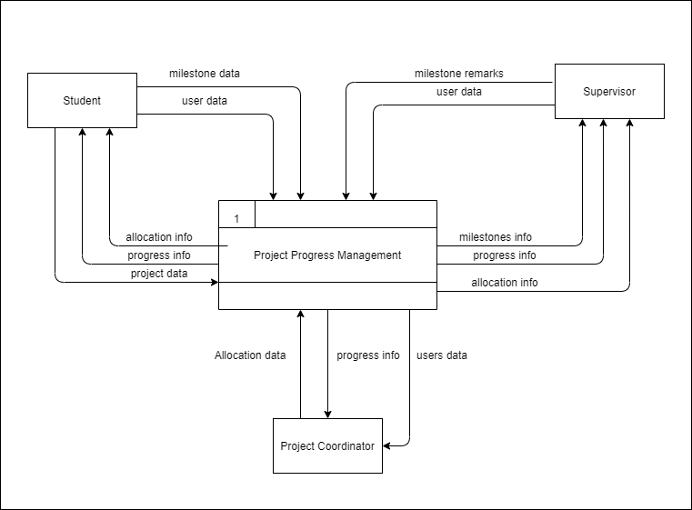

Figure 1: Level 0 DFD

#### Level 1 DFD

The process in the context diagram can be expanded further to represent details of the processing activities as shown in the level 1 DFD below.

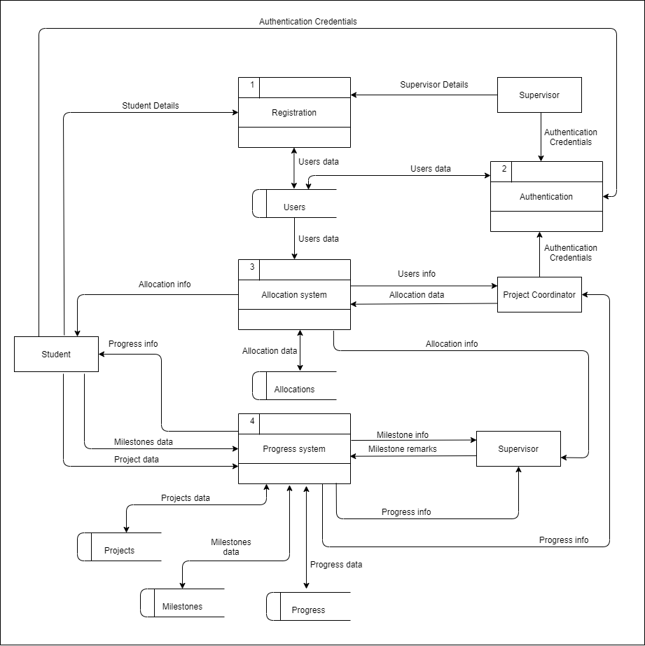

Figure 2: Level 1 DFD

#### Level 2 DFD

This level involves extracting a particular process that has a lot of data flow linking between a few external entities. The diagram below shows a level 2 DFD which extracts the progress system above into a separate diagram.

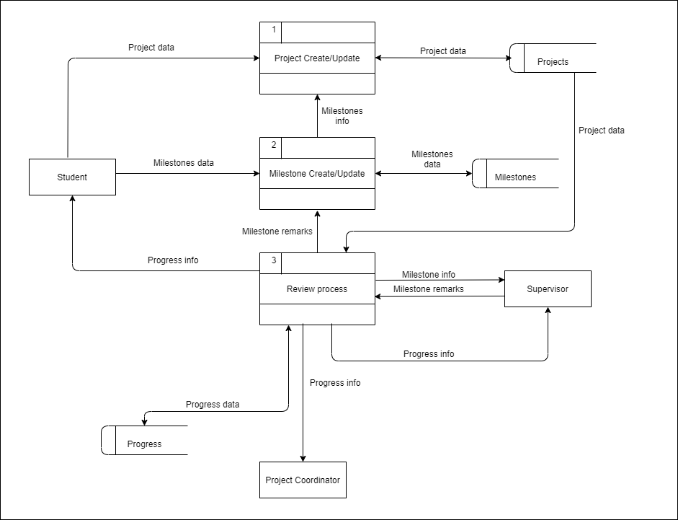

Figure 3: Level 2 DFD

### Use Case Diagram

A use case diagram models the functionality of a system using actors and use cases. Use cases are a set of functions that the system needs to perform. A use case diagram is valuable for visualizing the functional requirements of a software that will translate into design and development priorities. They help to identify any internal or external factors that may influence the system. The following is a use case diagram of SPPMS.

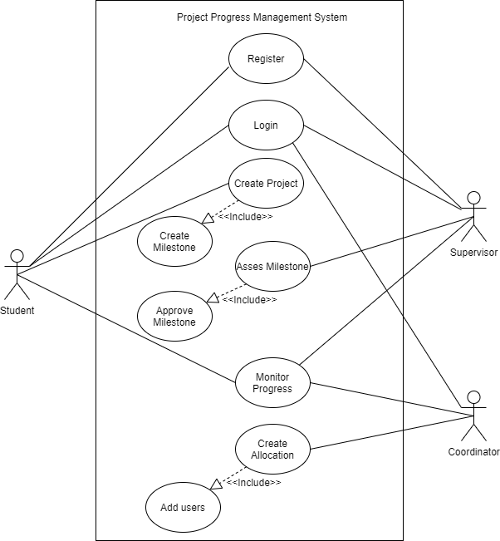

Figure 4: Use case diagram

### Class Diagram

A class diagram describes the types of objects in the software system and the different types of relationships that exist among them. It shows classes, their attributes, operations (or methods), and the relationships among objects.

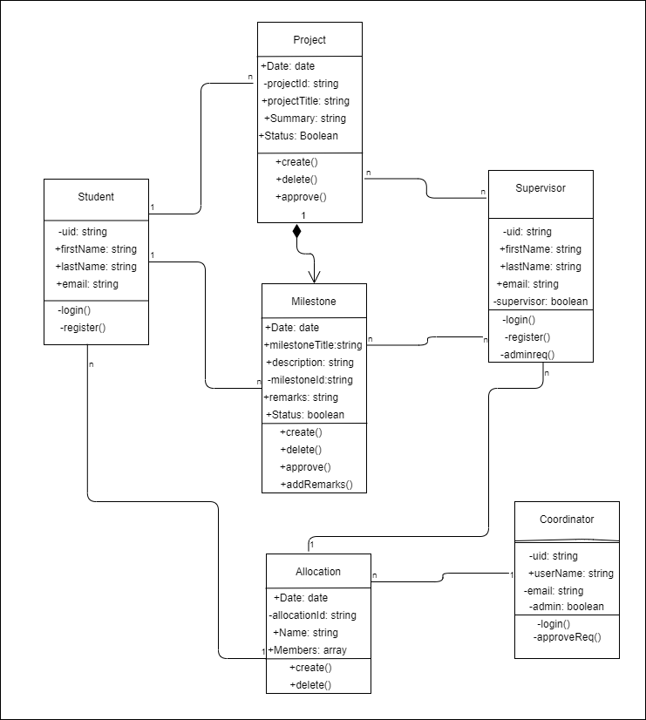

Figure 5: Class Diagram

### Flowcharts

A flowchart is a graphical representation of steps. It is used for representing algorithms and programming logic. It can play an extremely important role in displaying information and assisting reasoning. It helps us visualize the complex processes of a system.

#### Sign Up and log in

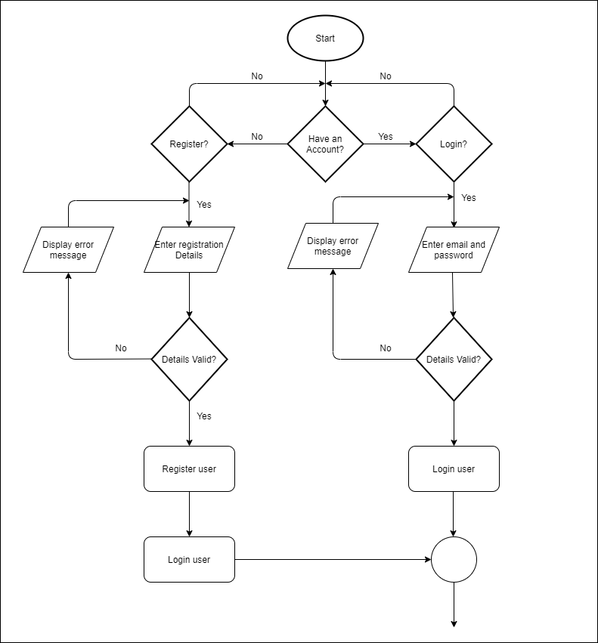

Figure 6: Sign Up & Sign In flowchart

#### Student’s Flowchart

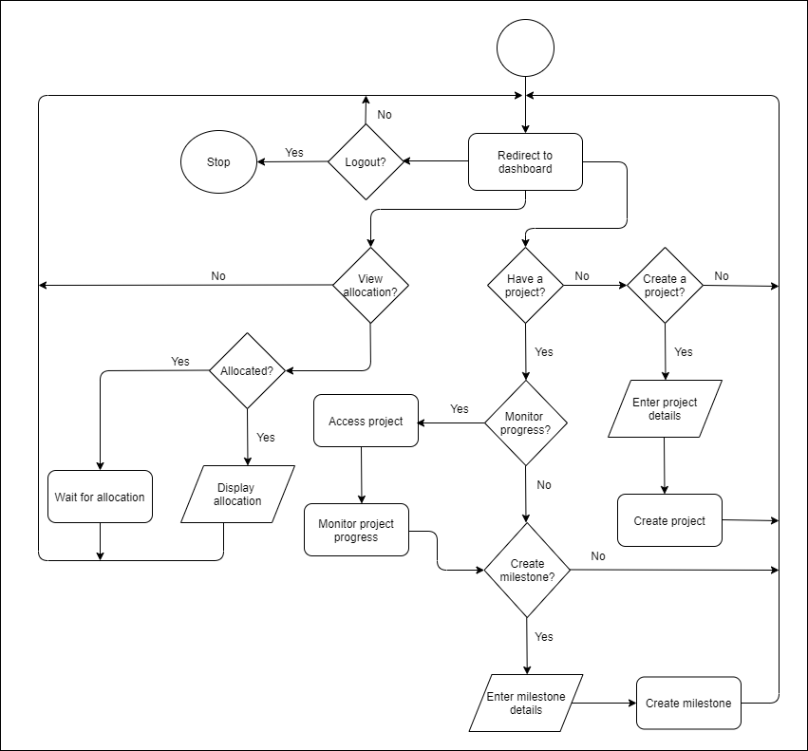

Figure 7: Students’ flowchart

#### *Supervisor’s Flowchart*

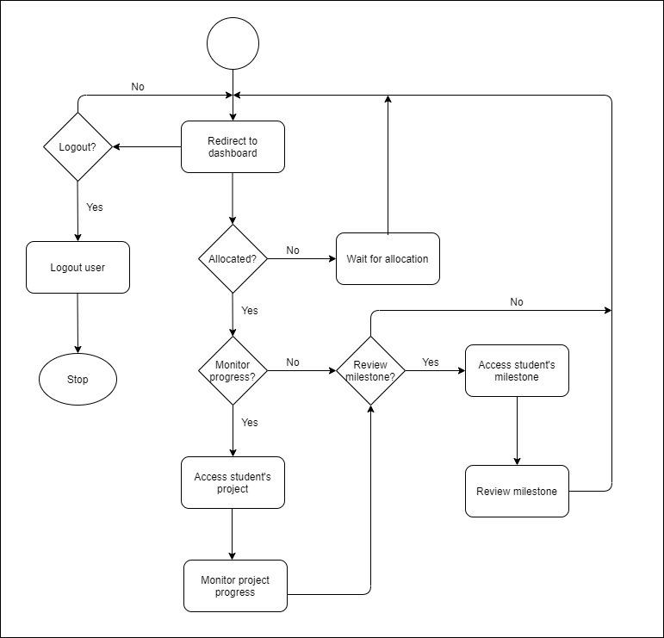

Figure 8: Supervisors’ flowchart

#### *Coordinator’s dashboard*

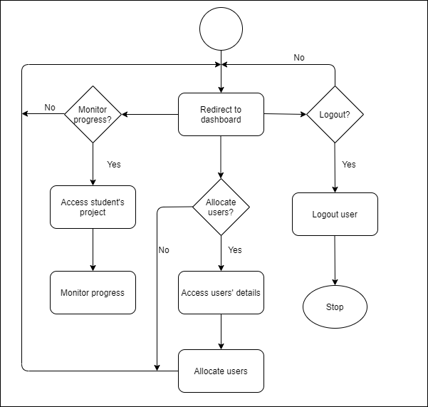

Figure 9: Project coordinators’ flowchart

## CHAPTER FIVE: SYSTEM DESIGN

### Introduction

System design is the process of defining the elements of a system such as the user interfaces and modules in order to meet the requirements of a system. This section focuses on the solution domain. It tries to answer, “How will the system be implemented?”

### Wireframes

A wireframe is a layout of a user interface that demonstrates what interface elements will exist on key pages. It is a critical part of the interaction design process. The aim of a wireframe is to provide a visual understanding of a page early in a project to get project team approval before the creative phase gets underway.

#### Sign Up and log in

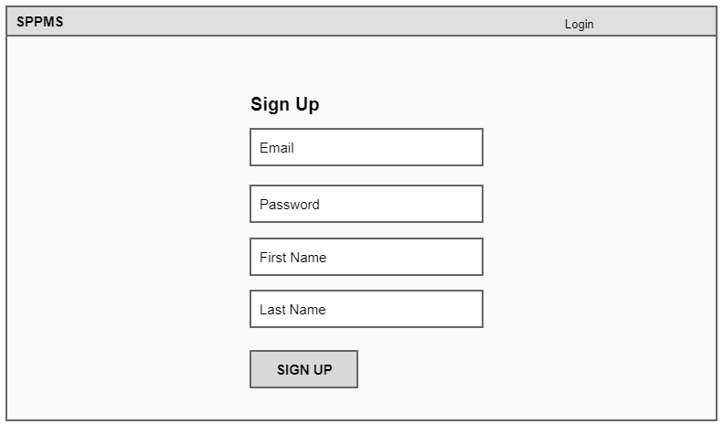

Figure 10: Sign Up wireframe

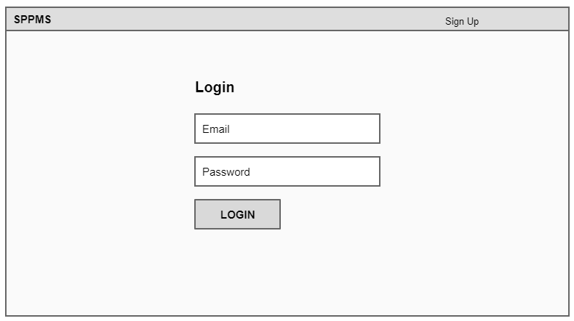

Figure 11: Login wireframe

#### Student dashboard

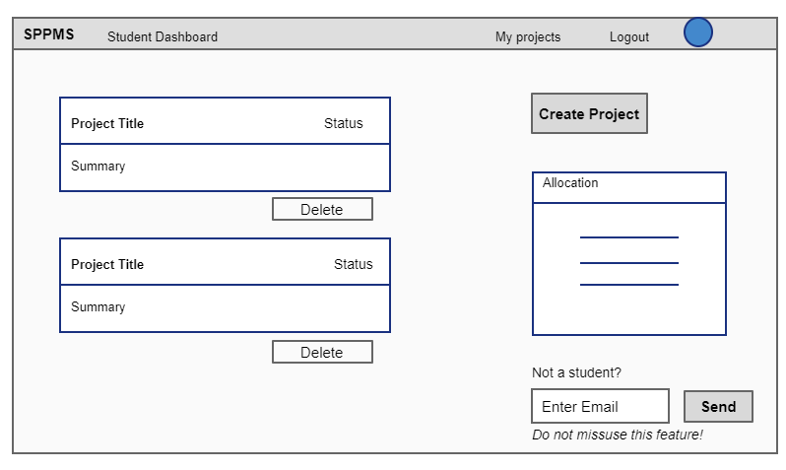

Figure 12: Students’ dashboard wireframe (a)

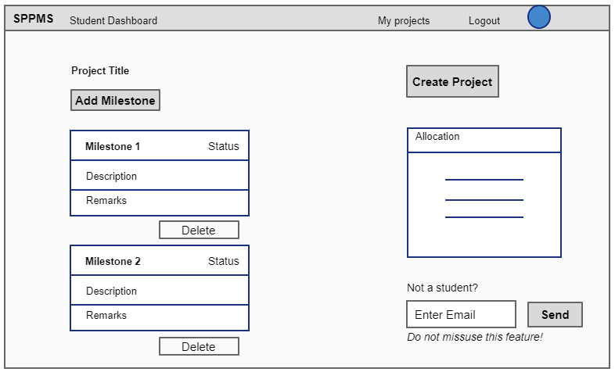

Figure 13: Students’ dashboard wireframe (b)

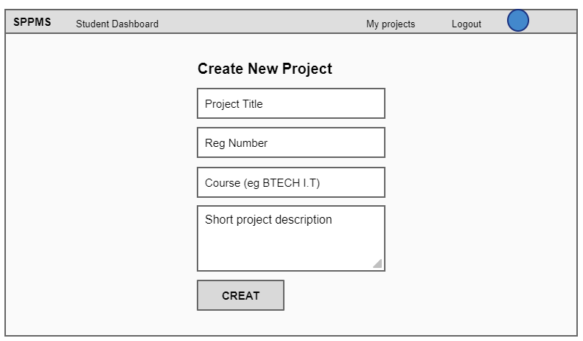

Figure 14: Add project wireframe

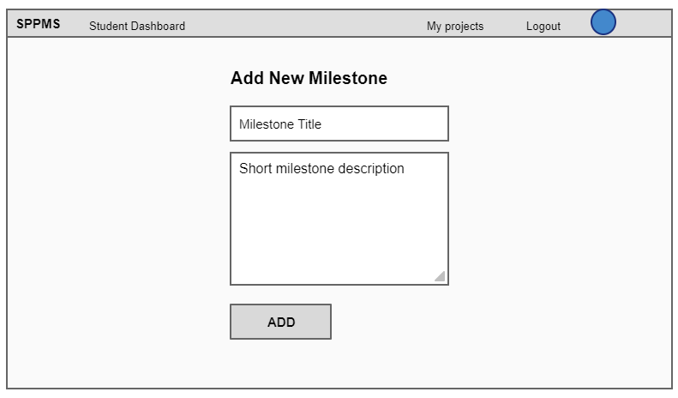

Figure 15: Add milestone wireframe

#### Supervisor dashboard

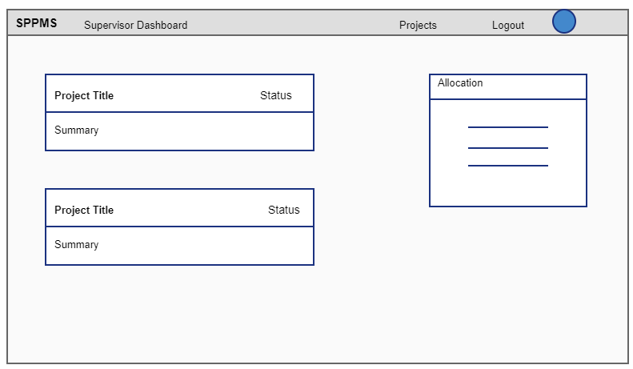

Figure 16: Supervisors’ dashboard wireframe

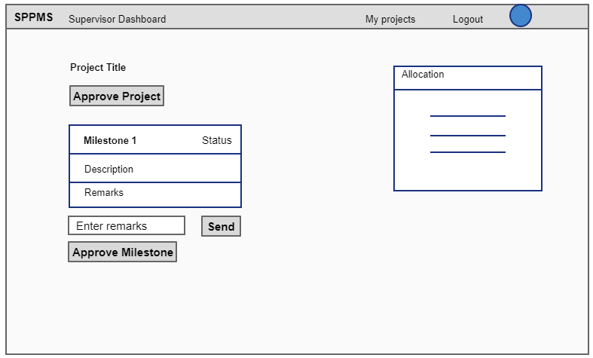

Figure 17: Approving milestones wireframe

#### Project co-ordinator dashboard

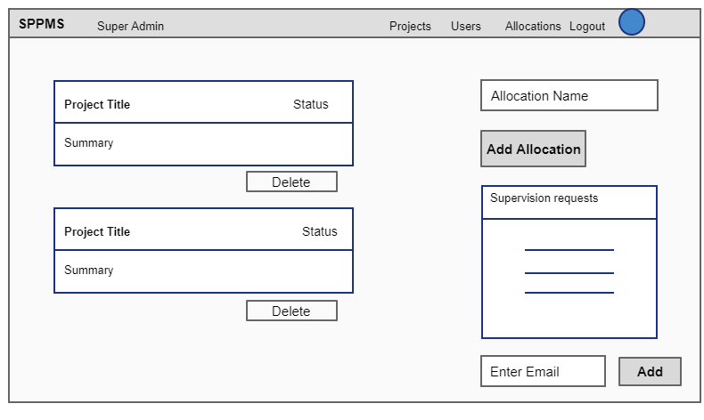

Figure 18: Project coordinator’s dashboard wireframe (a)

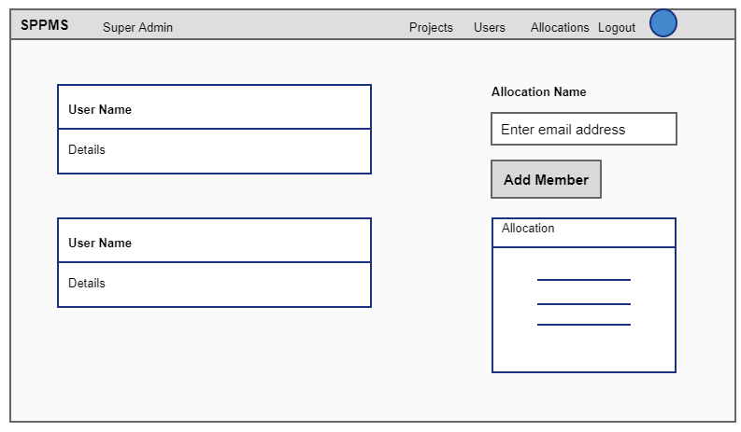

Figure 19: Project coordinator’s dashboard (b)

### Database schema

A database schema describes the structure of a database and is an organization of data that acts as a blueprint of how the database is constructed. It explains in detail the attributes of each entity in the database and the logical relationship that exist between these entities.

#### Conceptual database design

The main aim of conceptual design is to show the entities of the system and the relationship between them. It does not show all the details of the actual database structure. It is the simplest model among all.

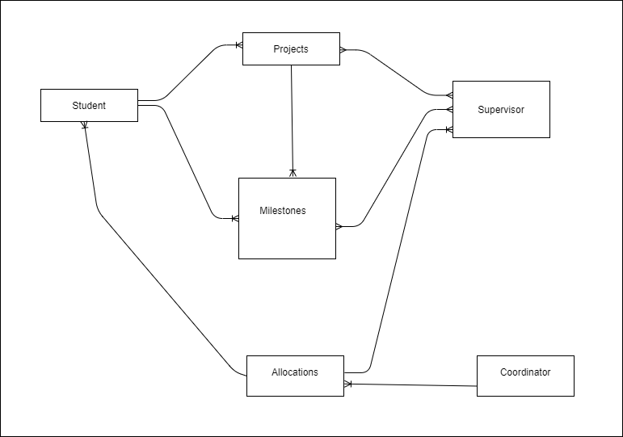

Figure 20: Conceptual database design

#### Logical database design

The logical design explains the database structure in a detailed way without regard to how the data will be physically designed in a database. All entities and relationships among them is show. All attributes of each entity are listed. In relation to the database, the primary key and foreign key are determined, and normalization happens in this level of database design. The following logical design shows the entities and their attributes only since SPPMS will be using a NoSQL database. There is no use of primary and foreign keys in NoSQL databases.

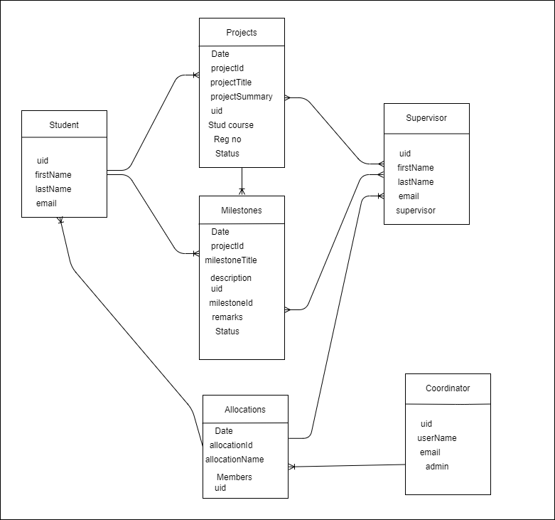

Figure 21: Logical database design

#### Physical database design

This level of database design shows how the database will be implemented. In a relational database, all tables, column names, column data types, primary key and foreign keys are included. In a NoSQL database, there are no tables, columns, primary keys and foreign keys. Collections, sub-collections, documents and subdocuments are used instead as shown in the following diagrams.

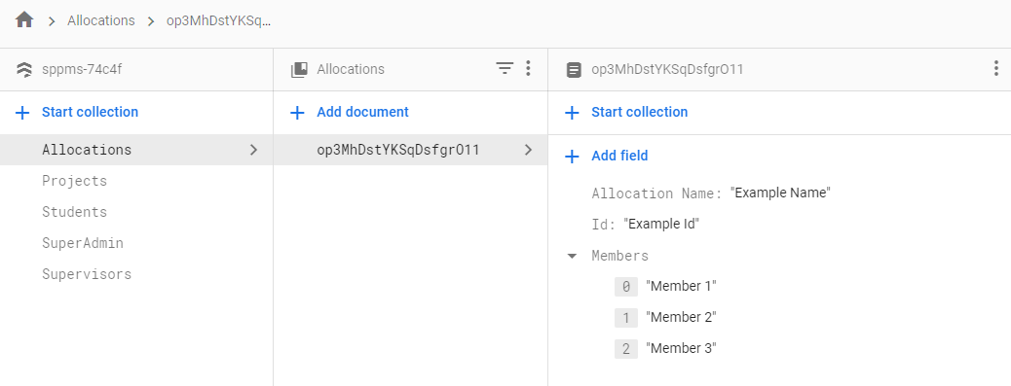

Figure 22: Allocations’ schema

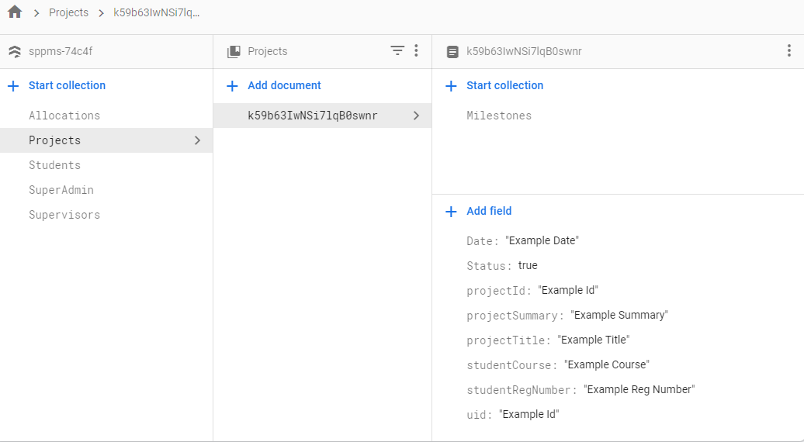

Figure 23: Projects’ schema

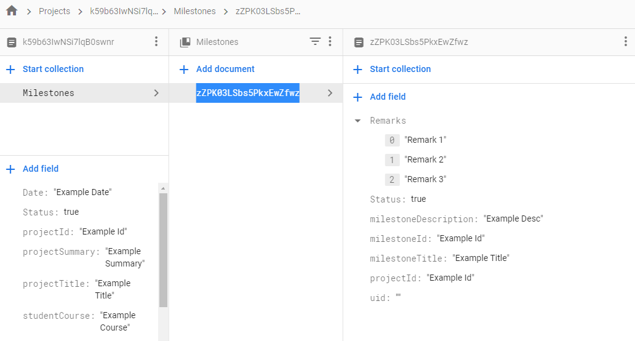

Figure 24: Milestones’ schema

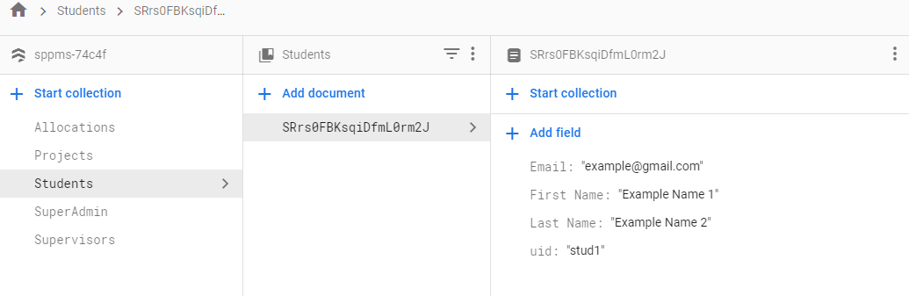

Figure 25: Students’ schema

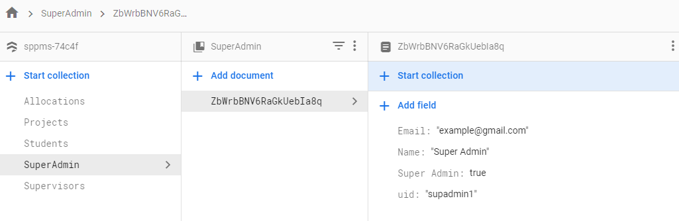

Figure 26: Project coordinator’s schema

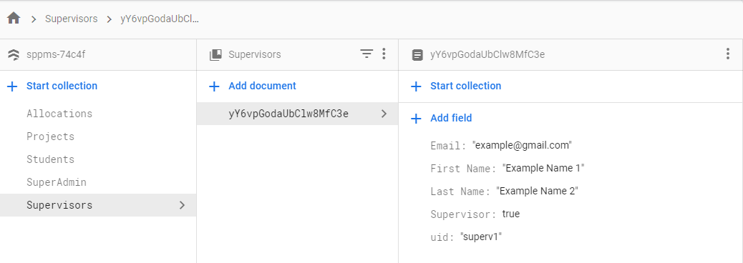

Figure 27: Supervisors’ schema

## CHAPTER SIX SYSTEM IMPLEMENTATION

# CONCLUSION

Students’ projects progress at the School of Computing and Information Technology at the Technical University of Kenya are currently managed manually by use of paperwork. This document has proposed a system that will automate the management of students’ projects with the following goals:

* 1. To eliminate paperwork in the management of students' projects progress.
  2. To improve students time management when doing their projects

# REFERENCE

Fuad, M., Latip, A., Khairul, M., Mat, A., Othman, M. M., Yassin, I. M., … Adnan, R. (2017). *International Journal of Advanced and Applied Sciences Implementation of fuzzy logic-based final year project student-supervisor matching system*. *4*(4), 159–163.

Kale, S., Shewale, A., Sarang, P. J., Pawar, P. S., & Sadruddin, S. (2017). *Project Management System ( PMS )*. *5*(2), 35–39.

Li, K. C., Wong, T. L., Cheung, S. K. S., Lam, J., & Ng, K. K. (2015). Technology in Education: Transforming Educational Practices with Technology: First International Conference, ICTE 2014 Hong Kong, China, July 2-4, 2014 Revised Selected Papers. *Communications in Computer and Information Science*, *494*(November 2016). https://doi.org/10.1007/978-3-662-46158-7

Mohamed, M. A., Abidin, A. F., Jamal, A. A., Amin, M. A. M., Rozaimee, A., & Wahab, F. A. (2017). An Implementation of Final Year Project Management System : A Case Study at Universiti Sultan Zainal Abidin. *World Applied Sciences Journal*, *35*(8), 1246–1251. https://doi.org/10.5829/idosi.wasj.2017.1246.1251

Thorat, A., Rahate, S., Jaiswal, I., & Gadhave, H. (2018). A Proposal for Final Year Project Monitoring and Assessment System. *International Journal of Scientific Research in Computer Science, Engineering and Information Technology*, *3*(3), 1245–1249. Retrieved from http://ijsrcseit.com/paper/CSEIT1833261.pdf

## Appendix